**22 june task**

The database consists of two tables account and t<accountno> .For each record in table account there exists a table t<accountno> .

As shown in following diagram

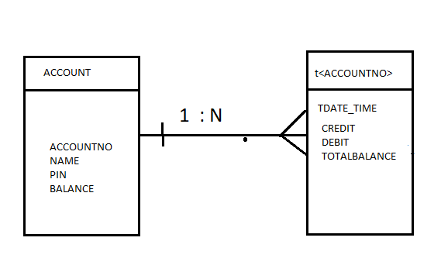

Where N is the no of rows in the table account.

Now elaborating about each table: -

ACCOUNT

This table contains the records of all the account holders in the bank as :

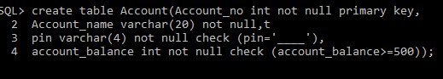

The snapshot of the table is shown: -

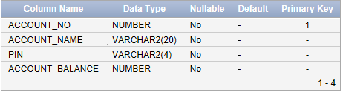

After creating the table, we can insert data as follows: -

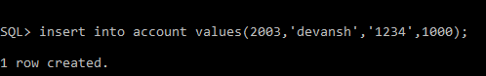

The table after inserting the value: -

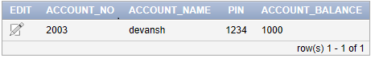

T<ACCOUNTNO>

There are equal number of these tables as there are accounts in the bank, each account has different table to store the transactions as : 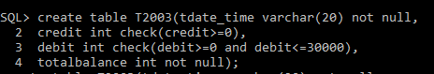

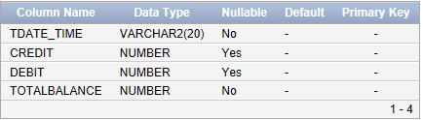

Now inserting values in the table by executing the following query: -

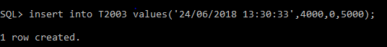

The snapshot of the table is as follows: -

